React Advanced (Hooks, Firebase, Redux)
Hooks:
Question 1: What are React hooks? How do use State() and useEffect() hooks work in functional components?
Answer: React Hooks are special functions that allow functional components to use state, lifecycle features, and other React capabilities without writing class components.
• use State(): Lets you create and manage state inside functional components. It returns a state value and a setter function.
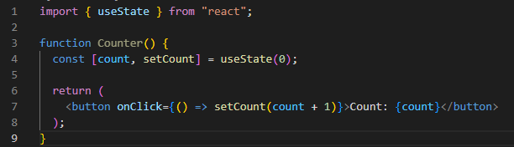
• use Effect(): Allows you to perform side effects such as fetching data, updating the DOM, timers, subscriptions, etc. It runs after render and can re-run when dependencies change.
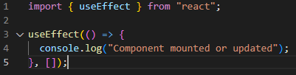
Question 2: What problems did hooks solve in React development? Why are hooks important?
Answer: Hooks solved many issues:
• Avoided complex class components.
• Allowed sharing logic without Higher-Order Components or render props.
• Made code cleaner, easier to test, and more reusable.
Hooks are important because they bring stateful logic to functional components and simplify component structure.
Question 3: What is useReducer? How is it used in React?
Answer: use Reducer is a hook for managing complex state logic. It works like Redux but inside a component.
• It takes a reducer function and an initial state.
• It returns the current state and a dispatch function.
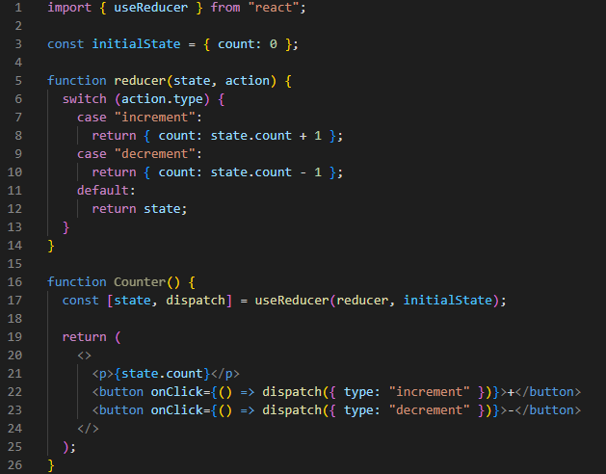
Question 4: What is the purpose of useCallback & useMemo Hooks? (Easy Explanation)
Answer: useCallback
- It remembers a function.
- React normally creates a new function every time the component runs.
- useCallback stops this and keeps the same function, unless something important changes.
Use it when:
You pass a function to a child component and you want to stop unnecessary re-renders.
useMemo
- It remembers a value.
- If you have a big calculation (slow or heavy), useMemo saves the result.
- It only re-calculates when needed.
Use it when:
You want to avoid heavy calculations every time the component renders.
Question 5: Difference between useCallback & useMemo?
Answer:
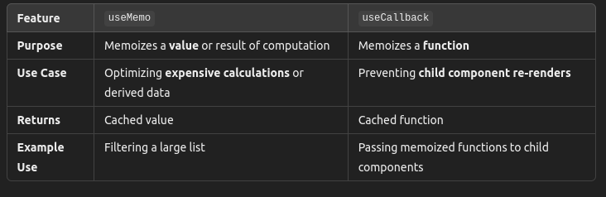
Question 6: What is useRef? How does it work?
Answer:
useRef creates a mutable reference object whose .current value persists across renders.
Uses:
• Accessing DOM elements
• Storing values that shouldn’t trigger re-renders
• Holding previous values
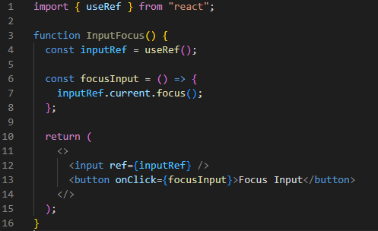

LAB EXERCISE
Task 1: Create a functional component with a counter using the useState()hook. Include buttons to increment and decrement the counter.
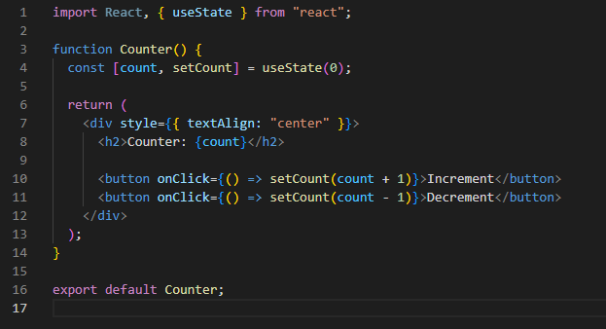
Task 2: Use the useEffect()hook to fetch and display data from an API when the component mounts.
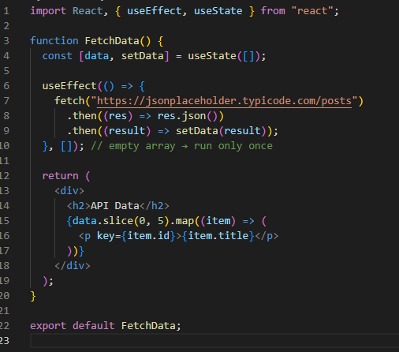
Task 3: Create react app to avoid re-renders in react application by useRef ?
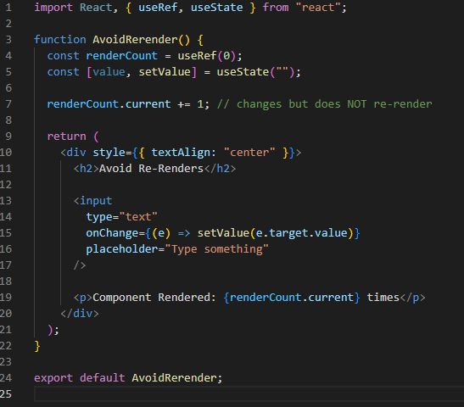

Redux:
THEORY EXERCISE
- What is Redux, and why is it used in React applications? Explain the core concepts of actions, reducers, and the store.
Answer: Redux is a state management library used in React application to manage global state in a predictable way.
- It helps when an app has a lot of components that need to share data.
- Data is usually passed from a parent to child components using props.
- But as the app grows, managing state across multiple components becomes complicated.
- Redux provides a centralized store where all components can access the necessary data without passing props manually.
The components of redux architecture
Action:
- It is like a message that tells Redux what to do.
- It is just a simple JavaScript object with a “type” property and sometimes extra data(payload)
Reducer:
- A reducer is a function that decides how the state should change when an action happens.
- It takes the current state and an action, then returns the new state.
Store:
- Store is like a big storage room that holds the entire state of the app.
- All components that need data can get it from the store instead of relying on props

LAB EXERCISE
Task 1: Create a simple counter application using Redux for state management. Implementactions to increment and decrement the counter.
counterSlice.jsx:
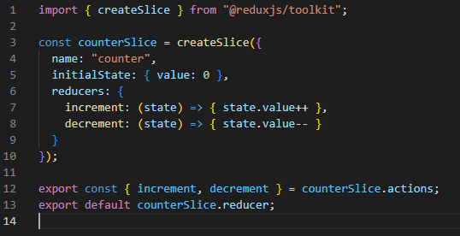
store.jsx:
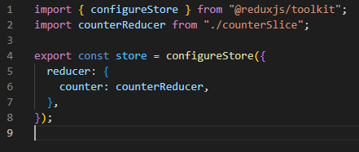
index.jsx:
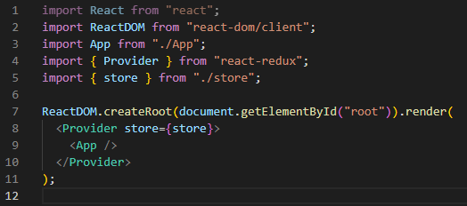
App.jsx:
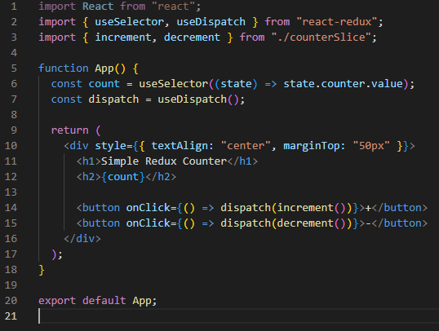
Output:
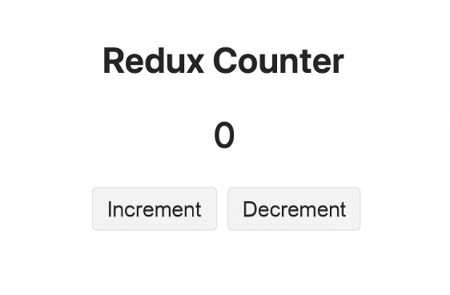

Firebase:
THEORY EXERCISE
1.What is Firebase? What features does Firebase offer?
Answer:
Firebase is a backend platform by Google that helps you build web and mobile apps without creating your own server. It provides ready-made backend services.

Features of Firebase
- Authentication – Login using email, phone, Google, etc.
- Firestore / Realtime Database – Store and sync data in real time.
- Cloud Storage – Store images, videos, and files.
- Hosting – Host websites and apps fast and securely.
- Cloud Messaging (FCM) – Send push notifications.
- Cloud Functions – Run backend code without servers.
- Analytics – Track user behavior and app performance.

